**CHAPTER 1**

**Organization & Structure of Industry**

**Codekul Pvt. Ltd**. was established in 2014 at Kothrud, Pune. The company is a training institute. The company trains students so to make them capable and professional industrial workers. Now the company is one of the leading training institutes at Pune. The company creates best that is required by each and every industry.

* The company is consisted of many teams who are professional in their own department.
* They have a big team to teach each and every technology what world demands.
* The company has many work such as web development, android application, game development, even softer development etc. the company has even staff members for training students.

As a result the students get knowledge of the real world.

**CHAPTER 2**

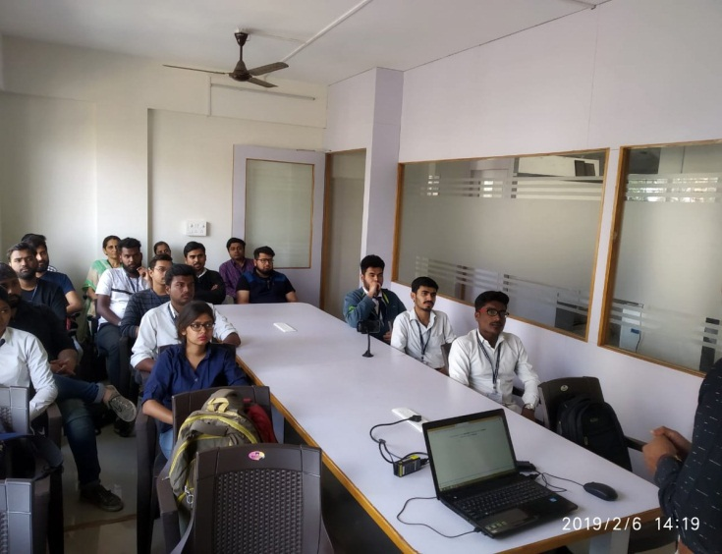**Introduction of Codekul Company**

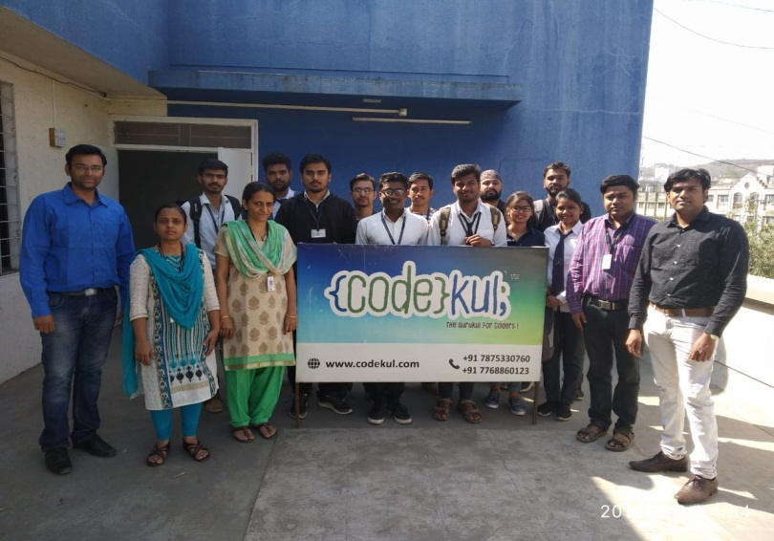

Our company (i.e. {code}kul; - The Gurukul for codes) was established in 2014 in Pune. The company was started with intention of startup in the mind of some friends. Now the company is one of the leading training institutes at Pune. The company is consisted of many teams who are professional in their own department. They have a big team to teach each and every technology what world demands. The company has many work such as web development, android application, game development, even softer development etc. the company has even staff members for training students.

The company follows their tag line “Implementation is more important than learning". They tell us students practicing the code more you will get the success than learning. The teaching staff mainly focuses on making students capable of self-learning and self updation. All the company employs have a very good knowledge and share with everyone.

Mission

* Implementation is more important than learning.
* More focus on implementation while training because now the world needs more implementer other than learner.
* “To produce technical expert according to Industries and also bring a positive attitude towards life for building a better nation”.
* To provide better future and career with the guidance of experienced, Experts, dedicated and talented trainers.

Vision

* Bridge the gap between students and corporate sectors by developing skilled resources who can build their career as per industry standard and they can start their own startup company.
* We create coders like cactus (they) our coders can survive their own all over the world.
* To Become the most respected IT Training, Corporate Training provider, Web application development and solution company in the world through world-class quality result oriented products and services with focus on emerging technologies where the best in the industry want to work for the job-satisfaction and professional growth it provides.
* To provide better future and career with the guidance of experienced, Experts, dedicated and talented trainers.

**CHAPTER 3**

**Working with Github**